UML DIAGRAM FOR LIBRARY MANAGEMENT SYSTEM

# AIM:

To draw UML diagrams for Library management system using Umbrello tool.

# USE CASE DIAGRAM:

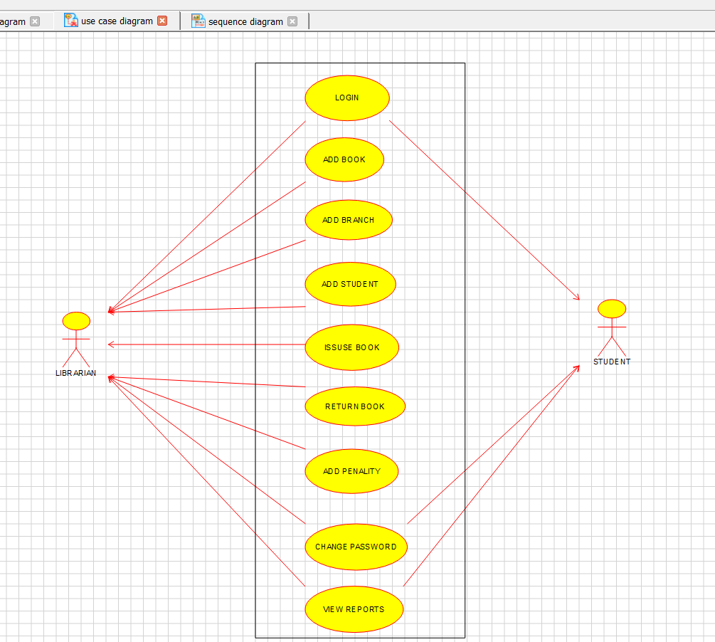

**CLASS DIAGRAM:**

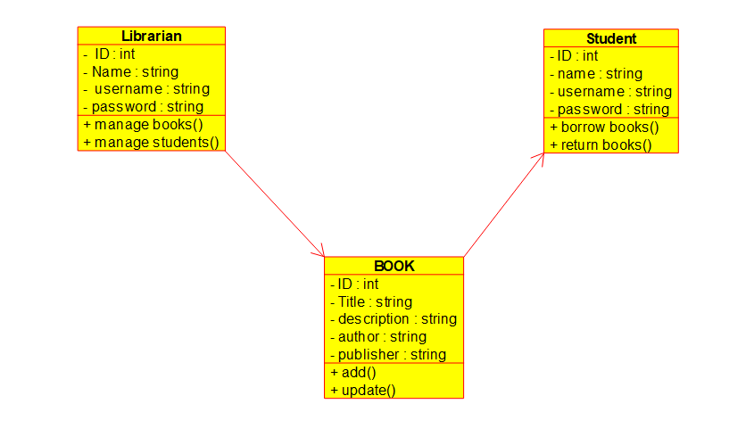

**ACTIVITY DIAGRAM:**

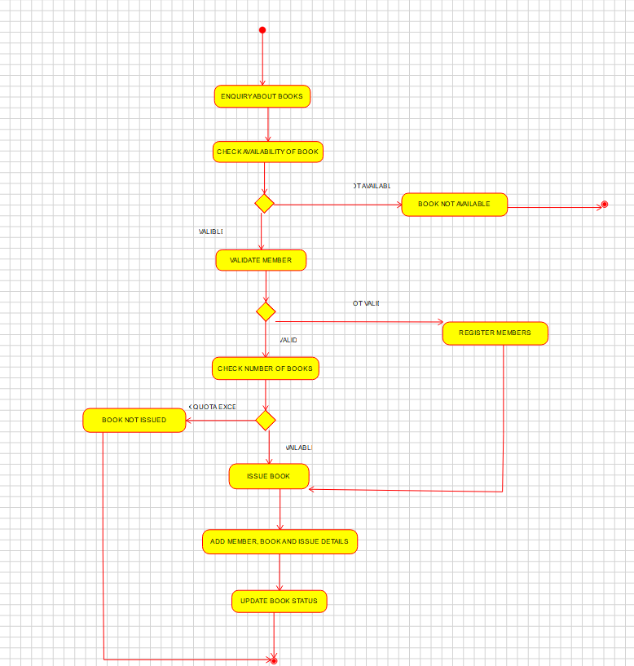

# RESULT:

Hence, the use-case diagram for online voting system is drawn and verified successfully.